Appendix A

1 DATABASE PLANNING

1.1 Mission Statement
The purpose of the Fantasy Soccer database is to support a web based fantasy soccer system which allows users to create and manage a fantasy soccer team, a league for fantasy teams and allows the review of real world and fantasy schedules, player and team history and statistics.

1.2 Mission Objectives
To maintain (enter, update and delete) data on real world players
To maintain (enter, update and delete) data on real world teams
To maintain (enter, update and delete) data on real world games
To maintain (enter, update and delete) data on fantasy teams
To maintain (enter, update and delete) data on fantasy leagues
To maintain (enter, update and delete) data on fantasy league commissioners
To maintain (enter, update and delete) data on system administrators
To maintain (enter, update and delete) data on fantasy team managers

To report on real world players
To report on real world games
To report on fantasy team statistics
To report on fantasy league statistics
To report on game schedules
To report on transfer history
To report on league rules
To report on system rules

To send weekly preview emails with current team, schedule and deadline reminder
To send e-mail notification to top three team managers each week, month, and overall

To secure access to data based on user type

1.3 Project Standards
Data Collection Methods
Player information via existing fantasy soccer league websites.
Game schedules via existing fantasy soccer league websites.
Player statistics via existing fantasy soccer league websites.
Game scores via existing fantasy soccer league websites.

Format Specification
Data format will be specified and maintained in a single shared data dictionary document.
Data format will mirror the format of collected data in general.

Documentation needed
Fantasy soccer league rules.
Fantasy soccer scoring rules.
Player evaluation formula (if not included in one of the other documents)

Design and Implementation
Design will proceed utilizing the database development life cycle.
Milestones will be utilized to track progress.

1.4 Key Terms

Fantasy Soccer League | A fantasy soccer league is a simulated soccer league where participants play the role of team managers and compete against each other based on each participants' skills of selecting the best players available for a given salary cap.
Salary Cap | Each team manager must pay a price when acquiring a player for his team. The price is determined based on the player's past performance and/or the level of demand for the player. Salary cap sets the maximum amount a team can spend on player acquisition.
Manager | A team manager's main responsibility is to select and/or replace players that constitute his team.
League Commissioner | A league commissioner creates one or more leagues and sets the rules that the teams in the league must follow.
System Administrator | A system administrator sets rules for how a participant in fantasy soccer league must select teams and how league commissioners can create leagues.

1.5 Policy Description
Registration Policy | All system users (players and league commissioners) must provide a valid and unique email address to register with the system. Players are not allowed to have more than one team on the system, enforced via uniqueness of their registration email address.
Scoring Policy | Game and player data will be updated nightly. Changes will be made if and only if the appropriate league governing body makes an official scoring change.
Team ranking Policy | Player’s teams will be ranked by the total number of points earned for that season (highest points to lowest points). In the event of ties, tied teams will be ranked in order of salary cap space available (most space available to least points available).

2 SYSTEM DEFINITION

2.1 Actors and their roles
Viewer:
A viewer is an individual who is browsing the fantasy soccer website, but has not registered as one of the other roles, or has not logged into the system.
Manager:
A manager is an individual who has registered with the system and logged in using their user ID and password. A manager has access to their team, their scores, and can make transactions involving their players. They can apply to join leagues and leave leagues.
League Commissioner:
A league commissioner is an individual who has registered with the system and logged in using their user ID and password. A league commissioner manages a league. They can invite team managers to join their league, see league statistics, and remove team managers from their league.
System Administrator:
A systems administrator is an individual who is authorized to maintain the fantasy soccer league and has logged in with their user ID and password. They can manage all parts of the system.
User:
A collective term for a someone who is logged into the system. This encompasses Managers, League Commissioners, and System Administrators

2.2 Systems Boundary
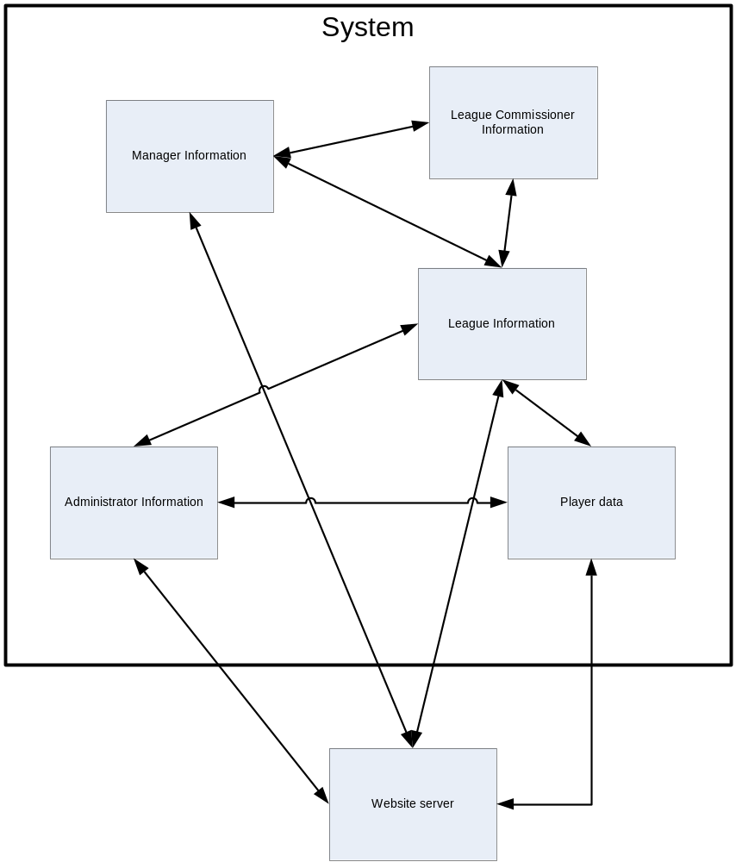

2.3 Major User Views Matrix
Data | Access Type | System Administrator | League Commissioner | Team Manager | Viewer
Manage All System Administrator  Accounts | Maintain | X
Manage All System Administrator  Accounts | Query | X
Manage All System Administrator  Accounts | Report | X
Manage System Administrator Account | Maintain | X
Manage System Administrator Account | Query | X
Manage System Administrator Account | Report | X
Manage All League Commissioner Accounts | Maintain | X
Manage All League Commissioner Accounts | Query | X
Manage All League Commissioner Accounts | Report | X
Manage League Commissioner Account | Maintain | X | X
Manage League Commissioner Account | Query | X | X
Manage League Commissioner Account | Report | X | X
Manage All Team Manager Accounts | Maintain | X
Manage All Team Manager Accounts | Query | X
Manage All Team Manager Accounts | Report | X
Manage Team Manager Account | Maintain | X |  | X
Manage Team Manager Account | Query | X | X | X
Manage Team Manager Account | Report | X | X | X
Manage All Teams | Maintain | X
Manage All Teams | Query | X | X | X
Manage All Teams | Report | X | X | X
Manage Team | Maintain | X | X | X
Manage Team | Query | X | X | X
Manage Team | Report | X | X | X
Manage Rules | Maintain | X
Manage Rules | Query | X | X | X
Manage Rules | Report | X
All Log in | Maintain | X
All Log in | Query | X
All Log in | Report | X
Login | Maintain | X | X | X
Login | Query | X | X | X
Login | Report | X | X | X
Create League | Maintain | X | X
Create League | Query | X | X
Create League | Report | X | X
Join League | Maintain | X | X | X
Join League | Query | X | X | X
Join League | Report | X | X | X
View Standings | Maintain | X
View Standings | Query | X | X | X | X
View Standings | Report | X | X | X
View Player Histories | Maintain | X
View Player Histories | Query | X | X | X
View Player Histories | Report | X | X | X
View Schedules | Maintain | X
View Schedules | Query | X | X | X | X
View Schedules | Report | X | X | X
Update Scores | Maintain | X
Update Scores | Query | X | X | X
Update Scores | Report | X | X | X

2.4 Use Case Summary
Name | Primary Actor | Goal
Manage Account | User | A User's registration information is updated in the fantasy soccer league web based system.
Manage Team | Manager | A Manager's team information is updated in the fantasy soccer league web based system.
Manage Rules | System Administrator | A System Administrator sets or changes system-wide rules affecting all future and/or existing leagues, teams, viewers, users, managers and/or league commissioners.
User Logs in | User | A User logs into the fantasy soccer league web based system
Create League | League Commissioner | A Manager becomes a League Commissioner by creating a league or a League Commissioner adds a league
Join League | Manager | A team manager joins an existing league, or becomes a member automatically by creating a new league.
View Standings | Manager | Manager’s team standing and the standings of other teams in the manager’s league(s) are presented to the manager.
View Player Histories | Manager | The player history of a selected player will be displayed for a Manager.
View Schedules | Viewer | A viewer browses the actual soccer league game schedules, past game results, and team standings.
Update Scores | System Administrator | Score information is added to the fantasy soccer web based system.

2.5 Use Cases
Manage Account
Name | Manage Account
Primary Actor | User
Goal | A User's registration information is updated in the fantasy soccer league web based system
Precondition | User has a valid account
Main Scenario | 1. User logs in using their login ID and password  2. User selects 'update account information'  3. User updates fields as needed.  4. User confirms update of information.  5. System saves the changes.
Alternate Scenarios | 3a. If user does not submit valid information, retain old data and prompt for valid entry.
Comments

Manage Team
Name | Manage Team
Primary Actor | Manager
Goal | A Manager's team information is updated in the fantasy soccer league web based system
Precondition | Manager has a valid account
Main Scenario | 1. Manger logs in using their login ID and password  2. Manager selects the manage my team  3. Manager makes trades, changes substitutions, team captain and or formation.  4. Manager confirms update of information.  5. System verifies updates  6. System saves the changes.  7. System provides success confirmation
Alternate Scenarios | 6. If user does not submit valid information, retain old data and prompt for valid entry.
Comments | Validity of information is determined by rules set by System Administrator

Manage Rules
Name | Manage Rules
Primary Actor | System Administrator
Goal | A System Administrator sets or changes system-wide rules affecting all future and/or existing leagues, teams, viewers, users, managers and/or league commissioners.
Precondition | System Administrator has a valid account
Main Scenario | 1. System Administrator logs in using their login ID and password  2. System Administrator adds a new rule or changes an existing rule affecting Teams, Leagues, Viewers, Users, Managers and League Commissioners.  3. System Administrator specifies the scope and effective date for each changes.  4. System Administrator confirms update of information.  5. System verifies updates  6. System saves the changes.  7. System provides success confirmation
Alternate Scenarios
Comments
User Logs In
Name | User Logs In
Primary Actor | User
Goal | A User logs into the fantasy soccer league web based system
Precondition | User has a valid account
Main Scenario | 1. User navigates to the website.  2. User enters their login ID and password.  3. User clicks the login button.
Alternate Scenarios | 3a. If login ID is not recognized, display an "Invalid login ID or password" message and do not allow login.  3b. If the password does not match the login ID, display an "Invalid login ID or password" message and do not allow login.
Comments | A system to recover forgotten password will also be available.

Create League
Name | Create League
Primary Actor | League Commissioner
Goal | A Manager becomes a League Commissioner by creating a league or a League Commissioner adds a league
Precondition | User has a valid account
Main Scenario | 1. User navigates to the website.  2. User clicks the create a league link  3. User provides league name  4. User provides email addresses and/or user names of initial league members  5. User clicks create league  6. System verifies data  7. System checks user type  8. System creates new entity instance  9. System sends out email notifications to invited members  10. System provides success confirmation to User
Alternate Scenarios | 8a. If User is Manager then User type is changed to League Commissioner
Comments

Join League
Name | Join League
Primary Actor | Manager
Goal | A team manager joins an existing league, or becomes a member automatically by creating a new league.
Precondition | Manager has a valid account
Main Scenario | 1. Manager logs in using their login ID and password  2. Manager select an existing league.  3. System checks if the Manager has been invited to join the league.  4. Manager is prompted to enter invitation confirmation number.  5. Manager enters invitation number.  6. System verifies data  7. System adds Manager to the league.  8. System provides success confirmation to User
Alternate Scenarios | 2a. If a Manager creates a new league, he becomes a member of the league automatically.  3a. If the Manager has not been invited to the league, the Manager receives rejection message.  5a. If the invitation number does not match the one issued to the Manager, the Manager receives error message.
Comments

View Standings
Name | View Standings
Primary Actor | Manager
Goal | Manager’s team standing and the standings of other teams in the manager’s league(s) are presented to the manager
Precondition | User has a valid account
Main Scenario | 1. Manager logs in using their login ID and password  2. Manager selects 'view standings'.
Alternate Scenarios
Comments | A manager will only see leagues they are a member of.

View Player Histories
Name | View Player Histories
Primary Actor | Team Manager
Goal | The player history of a selected player will be displayed for a Team Manager
Precondition | User has a valid account
Main Scenario | 1. Manager logs in using their login ID and password  2. Manager selects view my team  3. Manager selects a player to view  4. System displays player history
Alternate Scenarios | 2a. Manager selects the transfers link  3a. Manager selects a player not currently assigned to their team
Comments

View Schedules
Name | View Schedules
Primary Actor | Viewer
Goal | A viewer browses the actual soccer league game schedules, past game results, and team standings.
Precondition
Main Scenario | 1. Viewer selects game schedule, past game results, or team standing for the actual soccer league.  2. System retrieves and displays requested data.
Alternate Scenarios
Comments

Update Scores
Name | Update Scores
Primary Actor | System Administrator
Goal | Score information is added to the fantasy soccer web based system
Precondition | System Administrator has a valid account
Main Scenario | 1. User logs in using their login ID and password  2. System administrator selects 'update scores'  3. System administrator provides a properly formatted data file.  4. System saves the updates.
Alternate Scenarios | 3a. If system administrator does not submit a properly formatted file, prompt for valid file format.
Comments

3 REQUIREMENTS COLLECTION AND ANALYSIS

3.1 Users’ Requirements Specification
3.1.1 System Administrator View
Data Requirements
System Administrator
A System Administrator manages the Fantasy Soccer system. The administer must be able to create, manage and remove accounts of all user types. The administrator is further able to query, create and remove fantasy teams and leagues, and manage teams and leagues they have created. Finally the System Administrator is responsible for managing the rules, inputting real world data on players, leagues and teams. The data held on System Administrator includes user name, password, email address, registration date, first name, last name, post code, country of residence.
League Commissioner
A league commissioner creates, manages, and deletes leagues. A league commissioner must have a team in each league they manage. A league commissioner can have more than one league. The data held on league commissioner include user name, password, email address, registration date, first name, last name, post code, country of residence, gender, and date of birth.
Team Manager
A team manager creates, manages and deletes teams. A team manager cannot have more than one team. The data held on team manager include user name, password, email address, registration date, first name, last name, post code, country of residence, gender and date of birth.
Player
A player must contain all relevant information on each player in the soccer league. The data held on a player includes name, position, date of birth, the team he belongs to, player value (salary) and the country of origin.
Team
Team represents an actual soccer team that a player belongs to. The data held on a team includes name and league.
League
League represents an actual soccer league that a team belongs to. The data held on a league includes name.
Game
A game represents an actual game played or scheduled to be played between two actual teams. The data held on a game includes date, venue, game result (win or loss), game score, and opponents.
Player Statistics
Player statistics stores player's achievements at each game. The data held on player statistics include player, game, starting line up status, substitution status, number of goals scored, number of assists, number of penalty kicks attempted, number of penalty kicks made, number of saves (for goal keepers), yellow card, red card, and number of minutes played.
Fantasy League
Fantasy League is a league formed from fantasy teams. The data held on a team includes name, type (whether private or public), date created, league members, and league commissioner.
Fantasy Team
A fantasy team consists of a number of players. There is a maximum number of players allowed for each team. There are maximum number of players for each positions. A team must have a minimum number of players at each position to be able to participate in a league. The total value of players in the team must be less than the maximum allowed salary cap. The data held on team include team name, team manager, a list of players, team captain, and current team value.
Transaction Requirements
Data Entry
Update League Commissioner information.
Modify fantasy league data.
Delete fantasy league.
Remove fantasy teams from the fantasy league.
Cancel league commissioner status in a fantasy league.
Cancel membership.
Data queries
Query league settings.
Query league teams.
Query manager information for teams in league
Query game schedule
Query game results.
Query league standing.
Query fantasy league standing.
Query player profile/statistics.
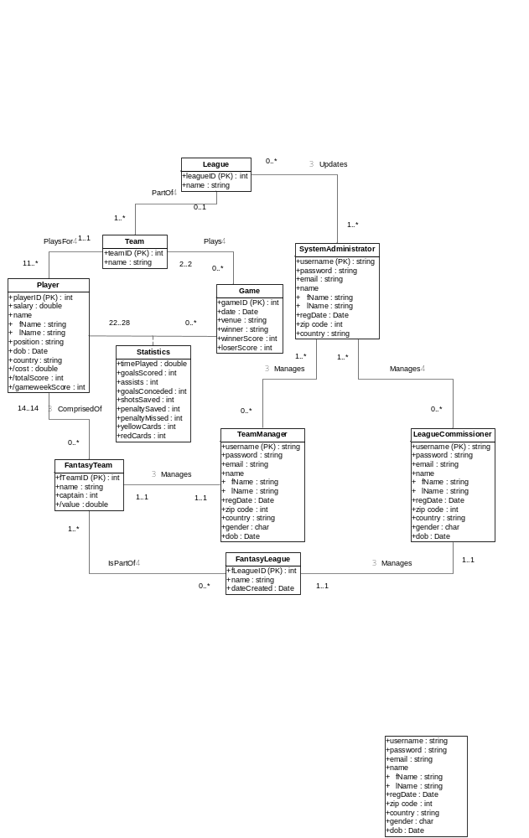
3.1.2 League Commissioner View
Data Requirements
League Commissioner
A league commissioner creates, manages, and deletes leagues. A league commissioner must have a team in each league they manage. A league commissioner can have more than one league. The data held on league commissioner include user name, password, email address, registration date, first name, last name, post code, country of residence, gender, and date of birth.
Team Manager
A team manager creates, manages and deletes teams. A team manager cannot have more than one team. The data held on team manager include user name, password, email address, registration date, first name, last name, post code, country of residence, gender and date of birth.
Player
A player must contain all relevant information on each player in the soccer league. The data held on a player includes name, position, date of birth, the team he belongs to, player value (salary) and the country of origin.
Fantasy Team
A fantasy team consists of a number of players. There is a maximum number of players allowed for each team. There are maximum number of players for each positions. A team must have a minimum number of players at each position to be able to participate in a league. The total value of players in the team must be less than the maximum allowed salary cap. The data held on team include team name, team manager, a list of players, team captain, and current team value.
Team
Team represents an actual soccer team that a player belongs to. The data held on a team includes name and league.
League
League represents an actual soccer league that a team belongs to. The data held on a league includes name.
Game
A game represents an actual game played or scheduled to be played between two actual teams. The data held on a game includes date, venue, game result (win or loss), game score, and opponents.
Player Statistics
Player statistics stores player's achievements at each game. The data held on player statistics include player, game, starting line up status, substitution status, number of goals scored, number of assists, number of penalty kicks attempted, number of penalty kicks made, number of saves (for goal keepers), yellow card, red card, and number of minutes played.
Fantasy League
Fantasy League is a league formed from fantasy teams. The data held on a team includes name, type (whether private or public), date created, league members, and league commissioner.
Transaction Requirements
Data Entry
Create new Team Manager
Create new League Commissioner
Create new System Administrator
Create new fantasy team
Create new fantasy league
Create new team
Create new player
Create new league

Data update/delete
Update Team Manager information
Update League Commissioner information
Update System Administrator information
Update fantasy team information
Add/remove players to fantasy team
Join fantasy league
Invite Team Managers to a fantasy league
Remove fantasy teams from fantasy league
Leave fantasy league
Delete Team Manager account
Delete League Commissioner account
Delete Fantasy League
Update player data
Update team data
Update league data
Delete player
Delete team
Delete league
Data queries
Query System Administrator accounts
Query League Commissioner accounts
Query Team Manager Accounts
Query players
Query teams
Query leagues
Query fantasy teams
Query fantasy leagues
Query game schedule
Query game results.
Query league standing.
Query fantasy league standing.
Query player profile/statistics.
Query league settings.
Query league teams.
Query manager information for teams in league

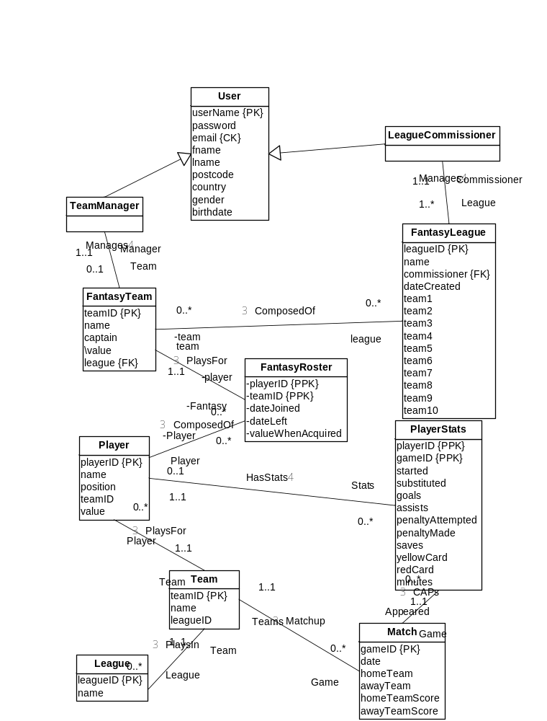

3.1.3 Team Manager User View

Data requirements

Team Manager
A team manager creates, manages and deletes teams. A team manager cannot have more than one team. The data held on team manager include user name, password, email address, registration date, first name, last name, post code, country of residence, gender and date of birth.

Fantasy Team
A fantasy team consists of a number of players. There is a maximum number of players allowed for each team. There are maximum number of players for each positions. A team must have a minimum number of players at each position to be able to participate in a league. The total value of players in the team must be less than the maximum allowed salary cap. The data held on team include team name, team manager, a list of players, team captain, and current team value.

Player
A player must contain all relevant information on each player in the soccer league. The data held on a player includes name, position, date of birth, the team he belongs to, player value (salary) and the country of origin,

Team
Team represents an actual soccer team that a player belongs to. The data held on a team includes name and league.

League
League represents an actual soccer league that a team belongs to. The data held on a league includes name.

Game
A game represents an actual game played or scheduled to be played between two actual teams. The data held on a game includes date, venue, game result (win or loss), game score, and opponents.

Player Statistics
Player statistics stores player's achievements at each game. The data held on player statistics include player, game, starting line up status, substitution status, number of goals scored, number of assists, number of penalty kicks attempted, number of penalty kicks made, number of saves (for goal keepers), yellow card, red card, and number of minutes played.

Fantasy League
Fantasy League is a league formed from fantasy teams. The data held on a team includes name, type (whether private or public), date created, league members, and league commissioner.

League Commissioner
League commissioner is a user who creates and manages a fantasy league. The data held on a league commissioner includes name, password, email address, registration date, first name, last name, post code, country of residence, gender and date of birth..

Transaction Requirements

Data Entry
Enter Team Manager/League Commissioner information.
Create a new fantasy team.
Add players to a fantasy team.
Join fantasy league.

Data Update/deletion
Update Team Manager/League Commissioner information.
Modify fantasy team data.
Delete fantasy team.
Remove/replace players in fantasy team.
Defect from fantasy league.
Cancel membership.

Data Queries
Query game schedule
Query game results.
Query league standing.
Query fantasy league standing.
Query player profile/statistics.

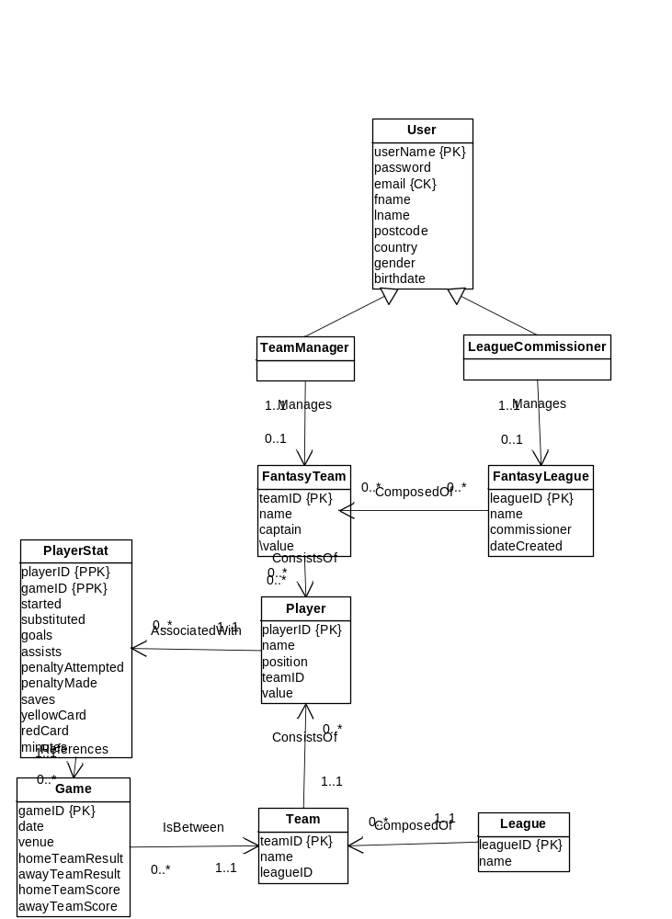

3.2 Systems Specification
Initial Database Size
- There are currently 3 System Administrators
- There are currently 574 real world team players
- There are currently 20 real world teams
- Initial System Administrator data will be imputed manually
- Team and player data will be imported
- No Team Manager Accounts, League Commissioner Accounts, Fantasy Leagues, or Fantasy Teams will be imported
Database Rate of Growth
- The number of administrators is expected to grow by five per year
- The number of league commissioners is expected to grow by one thousand per year
- The number of team manager is expected to grow by fifty thousand per year
- The number of real world teams is expected to grow by three per year
- The number of real world team statistics is expected to grow by twenty per week
- The number of real world player statistics is expected to grow by 574 per week
- The number of real world players is expected to grow by thirty per year
- The number of leagues is expected to grow by three thousand per year
The types and average number of record searches
- Each team manager is expected to run an average of two real world player queries per week
- Each team manager is expected to run an average of one real world team queries per week
- Each team manager is expected to run an average of three league queries per year
- Each league commissioner is expected to run an average of one league queries per week
- An administrator is expected to run a daily query on new accounts one month before and three months after the start of the season
- An administrator is expected to run a daily query on new leagues one month before and three months after the start of the season
- An administrator is expected to run a daily query on new teams one month before and three months after the start of the season
- An administrator is expected to run a weekly query on new accounts during the none peak months
- An administrator is expected to run a weekly query on new leagues during the none peak months
- An administrator is expected to run a weekly query on new teams during the none peak months
- Each user is expected to run an average of one system rule query per week during peak months
- Each user is expected to run an average of one league rule query per week during peak months
- Each user is expected to run an average of one system rule query per month during non peak months
- Each user is expected to run an average of one league rule query per month during non peak months
- Each user is expected to run a query on real world team schedules per week
- Each user is expected to run a query on their accounts each month
Networking and shared access requirements
- Viewers and Users will be able to access the Fantasy Soccer system from the public Internet
- The database and web interface will initially reside on the same system
- A high speed always on Internet connection will be used.
- The system will need to allow for up to 100 simultaneous connections.
Performance
- The month before and three months after the start of the real world season expect less than 1 second response time for all single record searches
- The month before and three months after the start of the real world season expect less than 2 second response for all multiple record searches
- During non peak months expect less than .33 second response for all single record search
- During non peak months expect less than .75 second response for all multiple record searches
- Total downtime for scheduled and unscheduled outages should not exceed 0.5%
Security
- All Users will use their email address as their system user name.
- All Users will input a strong password upon the creation of their account
- Users may change their password at any time but must provide their current password
- All sensitive information will be encrypted
- Access permissions will be used to restrict access to rules, account information and raw data
- Access to the website will be secure
Backup and Recovery
- Backups will be performed by a designated administrator
- Backups will occur at the beginning of weekly scheduled downtime between 0300 and 0400 local time on Wednesday mornings
- In the event of hardware failure, the website will suspend operations, the replacement will be set up and the most recent backup will be loaded
Legal Issues
- The system will reside in Tacoma, Washington and will comply with all relevant local, state and federal regulations.
- All transactions, to include registration, and queries, will be made across multiple jurisdictions and will comply with originating, destination and federal regulations

